Experiment: 3
Aim:
To write a Python program to solve the Water Jug Problem using Breadth-First Search (BFS) to obtain the required amount of water.
Algorithm:
- Start the program.
- Initialize both jugs as empty.
- Add the initial state to a queue.
- Remove a state from the queue and check whether the goal is reached.
- Generate new states by filling, emptying, or pouring water between the jugs.
- Add unvisited states to the queue.
- Repeat until the goal state is reached.
- Display the sequence of states and stop.
Code:
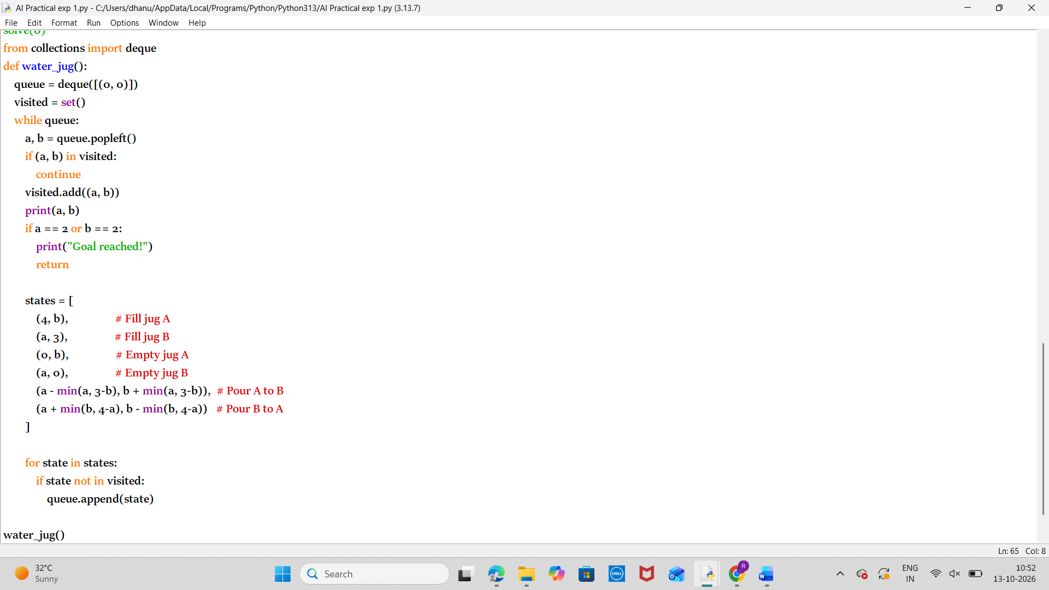

Output:
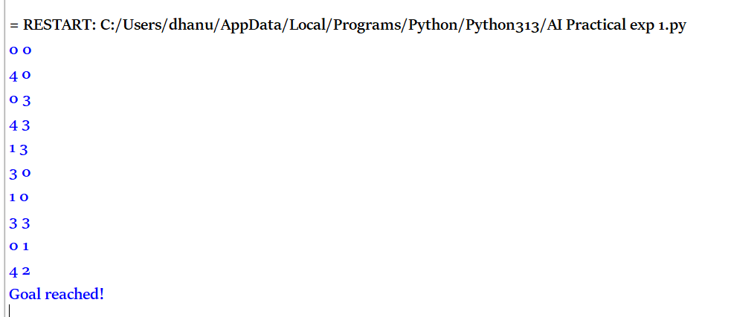
Result:
Thus the python program to run water jug problem is executed successfully.

